Stakeholder Identification Table
The following table identifies all primary and secondary stakeholders associated with the CIS platform, along with their role type, primary interests in the system, and their relative level of influence over design and acceptance decisions.

Stakeholder | Role / Type | Interest in CIS | Influence Level
Students | Primary End User | Course registration, grades, finance, club participation, timetable, and academic alerts. | Low – consume services
Teachers | Primary End User | Manage attendance records, gradebooks, course rosters, and communicate with students. | Medium – operate course workflows
Administrators | Operator / Manager | Provision accounts, maintain academic structure, manage finance, publish notices, and oversee system data. | High – control institutional data
System Owner | Governance Sponsor | Approve policy, validate acceptance criteria, oversee deployment, and ensure operational maturity. | High – strategic authority
IT / DevOps | Technical Stakeholder | Deployment infrastructure, environment configuration, backup procedures, and container management. | Medium – system reliability
Compliance / Auditors | External Oversight | Verify audit trail completeness, data privacy compliance, and security policy enforcement. | Medium – regulatory requirements

Each stakeholder group has been considered during requirements elicitation. Functional requirements are traceable to at least one primary stakeholder group, and acceptance criteria have been validated against the interests and authority of the System Owner and Administrator stakeholders who carry the highest institutional influence over the deployment decision.

Ongoing stakeholder engagement, particularly with teachers and students during user acceptance testing, is recommended to validate that role-specific workflows meet operational expectations before full institutional deployment.

Onion Model Diagram
The Onion Architecture model is adopted for CIS to ensure that core domain logic remains independent of external concerns such as database drivers, UI frameworks, and third-party integrations. This architectural approach promotes modularity, testability, and long-term maintainability by enforcing strict dependency direction: outer layers depend on inner layers, never the reverse.

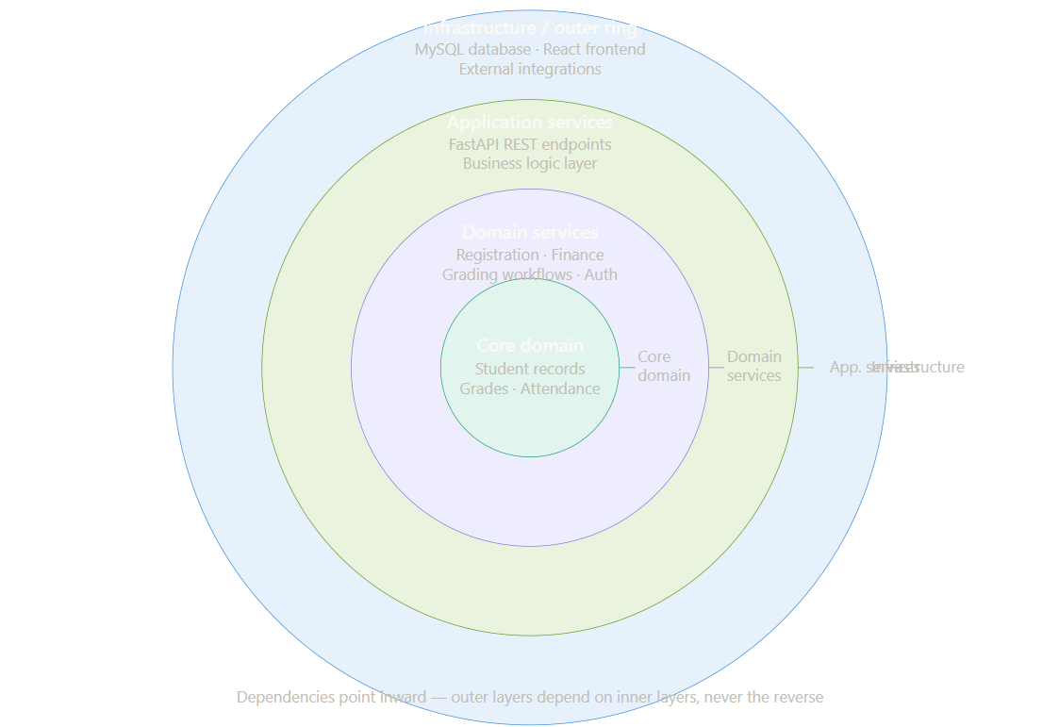
At the core of the architecture are the domain entities that represent the fundamental academic and operational concepts of the institution: students, courses, grades, registrations, invoices, and their associated rules and lifecycle states. These entities are independent of any framework, database technology, or interface concern.

The domain services layer encapsulates the business logic that operates on core entities — registration validation, grade publication workflows, finance hold enforcement, and authentication token management. These services know the domain rules but remain agnostic of how data is persisted or how requests arrive.

The application services layer coordinates use cases and orchestrates the interaction between domain services, repositories, and external interfaces. FastAPI route handlers and dependency injection patterns operate at this layer, translating HTTP requests into domain operations and formatting responses for API consumers.

The outermost infrastructure layer encompasses all external concerns: the MySQL database and its ORM adapter, the React frontend that consumes the REST API, and any future integrations with email services, payment processors, or analytics platforms. These components are replaceable without affecting the inner layers.

